9. TACTICAL THEME:
DEMOLITION OF PAWN STRUCTURE

This tactical theme focuses on opening up or getting rid of the pawn structure around the castled king eventually giving mate or winning big material.

1. White mates/Black mates 2. White wins/Black wins
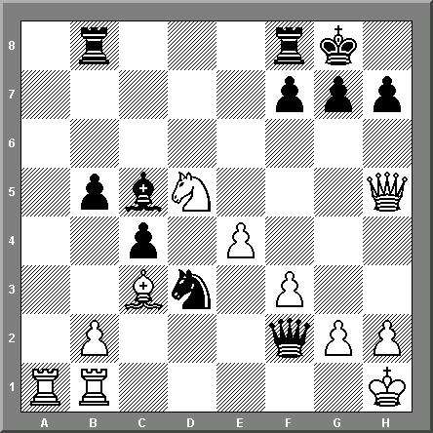
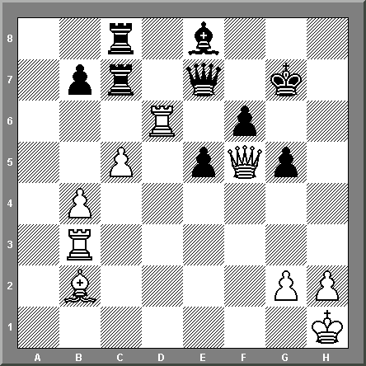

3. White mates/Black wins 4. White mates/Black to win
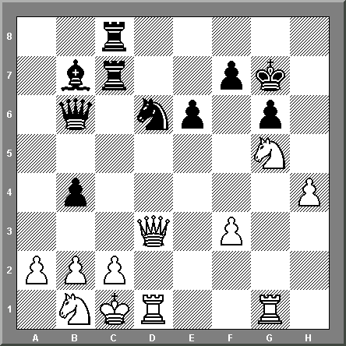
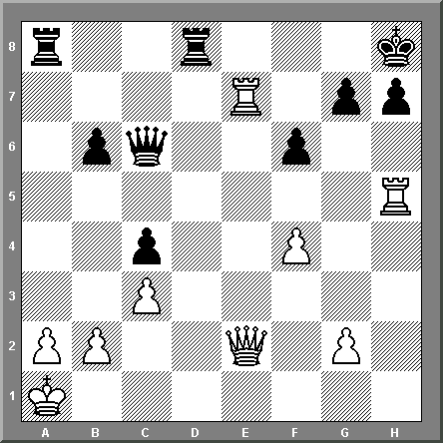

5. White mates/Black mates 6. White mates/Black mates
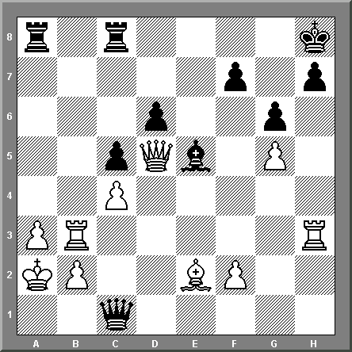
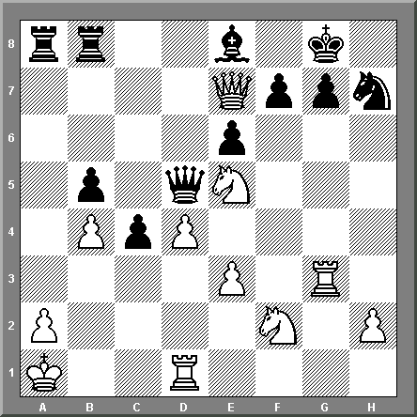

7. White mates/Black wins 8. White mates/Black wins
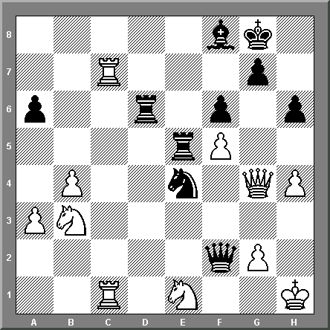
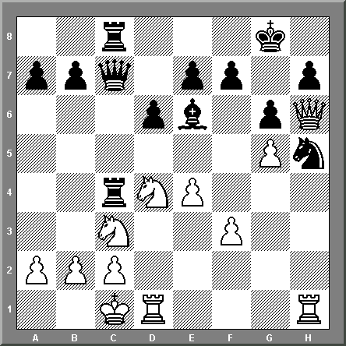

9. White mates/Black mates 10. White mates/Black mate/win
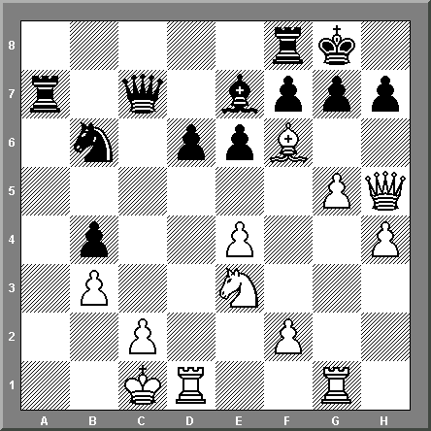
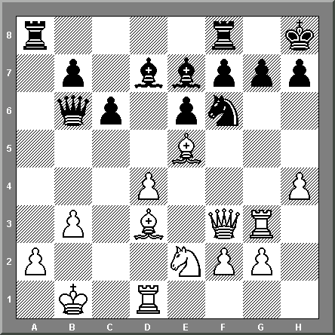

11. White mates/Black wins 12. White wins/Black mate/win
